**Labrador Sea Meeting November 25th 2024**

Consensus on one report for physics/chemistry/biogeochemistry.

* Zeliang has a product (winter convection Depth) that is reproducible and will be published so users can refers to the method
* TTD method is being developed by Carrie-Ellen et al. and will be ready in the new year. We can compare her results for winter convection depth with results from Zeliang.
* For the rest of Chemistry, figures will be business as usual
* Chris is using Zeliang’s method for MLD but with argo floats data

Here is an example of Chris’ figure downloaded from Github, this is the temperature seasonal cycle for several layers… pretty cool!

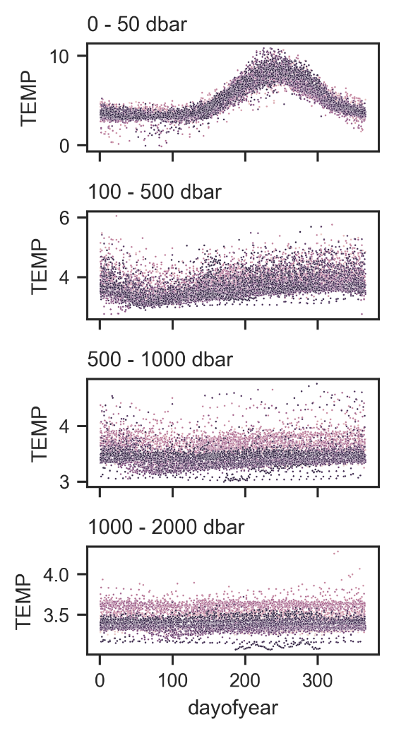

Current Climatology is 2000 to 2020 except for ocean colour satellite but starting in 2024, we will use Ocean Colour – Climate Change Initiative dataset which will cover 1999 to current.

Blair: all anomalies should be the same.

**2001-2020**:20-year climatology decided by poll

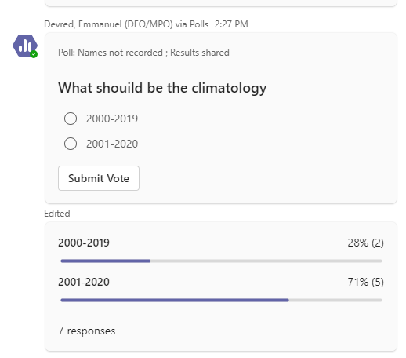

1999-2020 – climatology in AZMP biogeochemistry

1991-2020 – climatology for AZMP physics

**Data processing status:**

Chemistry

Behind for some data, Alkalinity/TIC should be done before March reporting though

pH is done fresh so up-to-date

Biogeochemistry:

* CTD being processed and should be done by early December (swap of sensors several time during mission complicated the processing)
* Nutrients – currently being processed by Peter, should be done in the coming weeks ** they have been filtered
* Chl-a is done
* HPLC is being processed
* Starting counting mesozooplankton this week and should be done before March reporting